CM3103: High Performance Computing
Coursework – 1
This report is for the High Performance Computing (Assignment 1) which represents and interprets the result of the experiments.

3.
After running blur.c
Input file - David.ps Output file - David.ps



Computational Times:
- 0.058691 seconds elapsed
- 0.058657 seconds elapsed
- 0.058487 seconds elapsed
- 0.058544 seconds elapsed
- 0.058615 seconds elapsed
- 0.058635 seconds elapsed

Average of these computational times = 0.071192

No. of computational times (N) = 6
Sum of all computational times (S) = 0.351629
mean (u) = 0.058604833333333

variance (v) = √1/N ∑(t_{i –} u)²
= 4.7908055555557 * 10⁻⁹

Standard deviation of these computational times = √(v)
= √( 4.7908055555557 * 10⁻⁹ )

4(a).
After running blurOMP.c

For Dynamic Scheduling
Input file, David.ps Output file, DavidOMP.ps
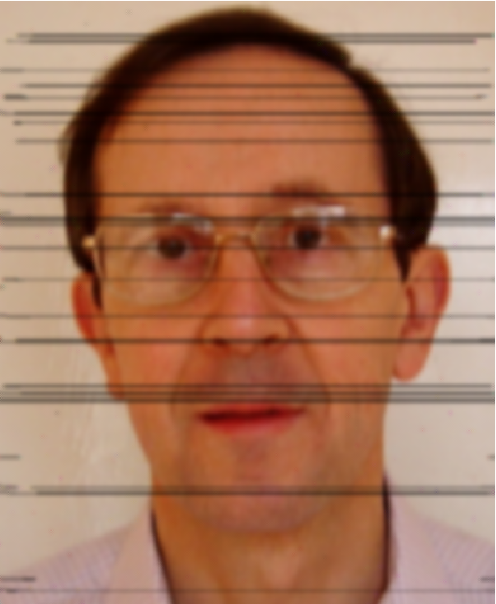


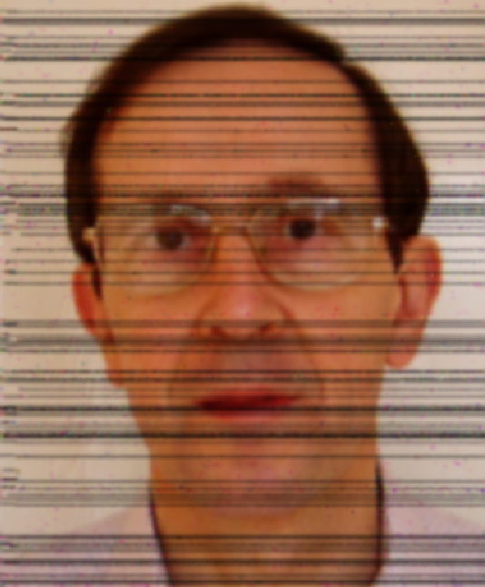

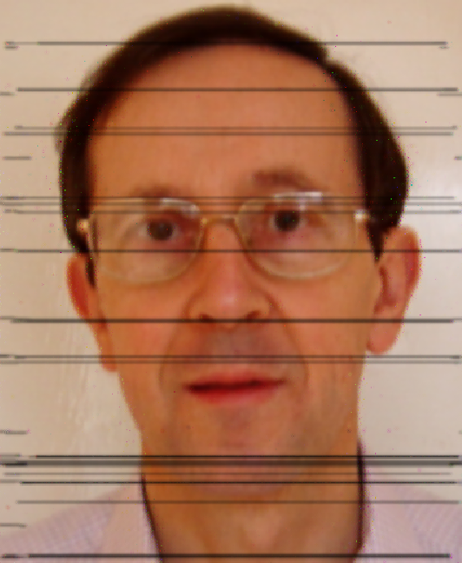

No. of Threads – 12 No. of Threads – 4 No. of Threads – 6 No. of Threads – 8 No. of Threads – 10 No. of Threads – 16
Chunk-size - 5 Chunk-size – 8 Chunk-size – 8 Chunk-size – 9 Chunk-size – 2 Chunk-size – 4
Computational Times :
- 0.117596 seconds elapsed
- 0.129693 seconds elapsed
- 0.136492 seconds elapsed
- 0.121701 seconds elapsed
- 0.135334 seconds elapsed
- 0.143122 seconds elapsed

Average of these computational times = 0.13065633333333
Standard deviation of these computational times = 0.0087847095316553

For Static Scheduling

Input file - David.ps Output file -DavidOMP.ps







No. of Thread – 12 No. of Threads – 4 No. of Threads – 6 No. of Threads – 8 No. of Threads – 10 No. of Threads – 16
Chunk-size – 5 Chunk-size – 8 Chunk-size – 8 Chunk-size – 9 Chunk-size – 2 Chunk-size – 4

Computational Times :
- 0.075955 seconds elapsed
- 0.110487 seconds elapsed
- 0.100887 seconds elapsed
- 0.077979 seconds elapsed
- 0.120660 seconds elapsed
- 0.164506 seconds elapsed

Average of these computational times = 0.10841233333333
Standard deviation of these computational times = 0.029824782556719

5(a). A description of the hardware and software environment.

Hardware Environment - Intel(R) Core(TM) i5-7200U CPU 2.50GHz processor (Quad Core), RAM (8GB), SSD
Software Environment - Linux (OS), Visual Studio(IDE) and Atom(Editor)

5(b). A description of the timing experiments carried out.

For the blur.c, I have compiled and ran the program 6 times and got different elapsed times. Evaluated the average of these times and standard deviation to measure the dispersion of these elapsed times.

For blurOMP.c, I have compiled and ran the program 6 times for dynamic and static scheduling respectively with different number of threads and chunk size values; and got different elapsed times. Evaluated the average of these times and standard deviation to measure the dispersion of these elapsed times.

5(c). Appropriate graphs of your timing experiments

Graph of Timing Experiment of blur.c
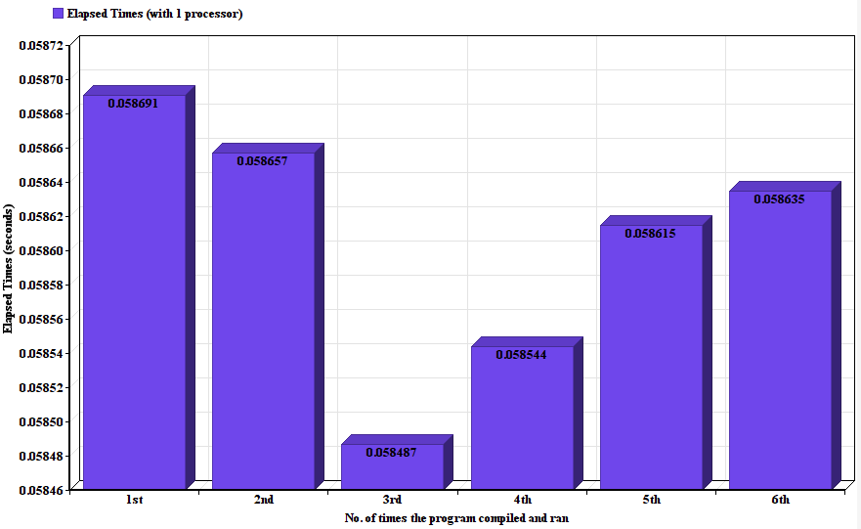
This graph represents the elapsed times for the each time blur.c has been compiled and ran.
Y-Axis shows all range of the times.
X-Axis shows the number of times program has been compiled and ran.

Graph of Timing Experiment of blurOMP.c

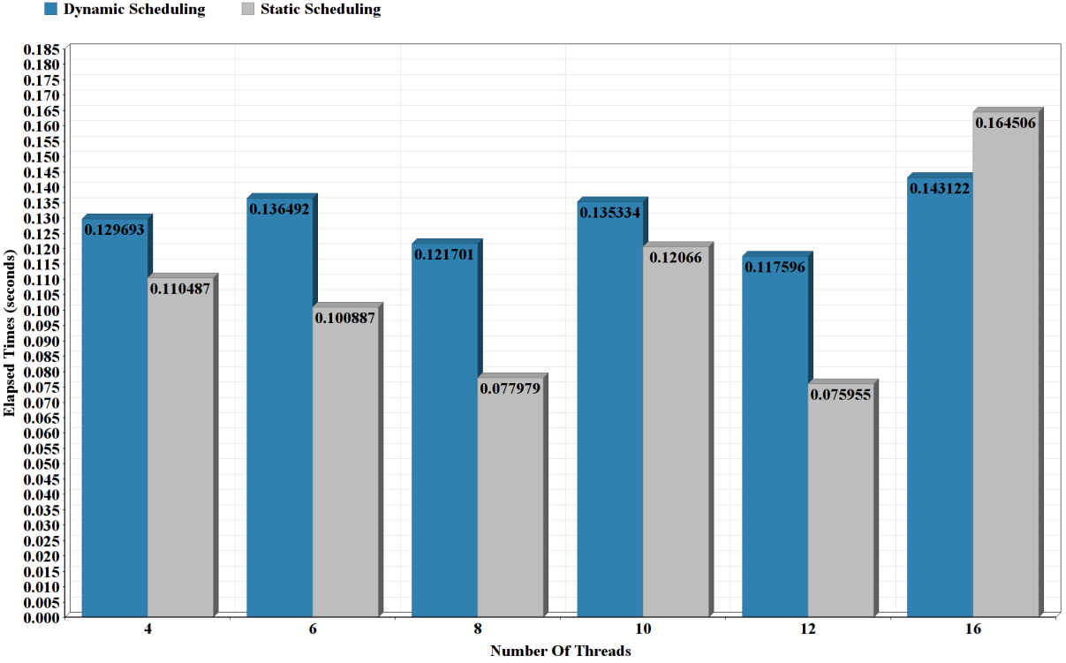

This graph represents the elapsed times taken against No. of threads for the dynamic and static scheduling.
Y-Axis shows range of the elapsed times.
X-Axis shows the number of threads used for the both scheduling.

5(d). A discussion of the results that demonstrates a qualitative understanding of
the timings, and accounts for any unusual features.
In the blur.c file, while running the program several times the output postscript file (DavidBlur.ps) showed very insignificant changes (blurriness remained the same) and the difference between all the elapsed times were very minimal.

In the blurOMP.c file, while running the program several times with the different number of threads and chunk size values for the dynamic and static scheduling respectively; the output postscript file (DavidBlurOMP.ps) showed significant amount of changes i.e increase in the blurriness, lines and noises in the output file. The difference between the elapsed times of dynamic and static scheduling varies significantly. Average elapsed time of the dynamic scheduling is 0.13065633333333 and average elapsed time of the static scheduling is 0.10841233333333 .

5(e). A short section presenting any overall conclusions, and giving a reflection on
what you have learned from this coursework.
From this coursework, I have learned about the OpenMP directives and how they are used for parallelization. I have also learnt mechanism of the static and dynamic scheduling and how they are used with different number of threads and chunk size which effects the computational time of the program.

